Research Scratchpad

Boards

Raspberry Pi Zero 2 WH
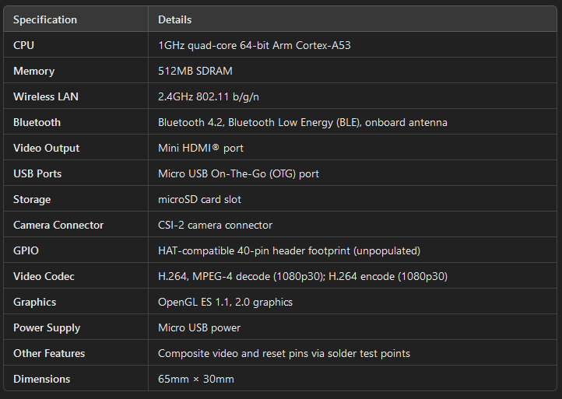
https://datasheets.raspberrypi.com/rpizero2/raspberry-pi-zero-2-w-product-brief.pdf
https://thepihut.com/products/raspberry-pi-zero-2?src=raspberrypi

Raspberry Pi Pico WH
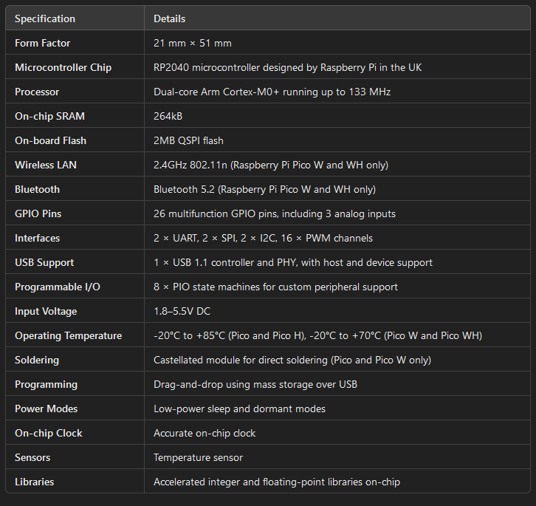
https://www.sgeducation.ie/raspberry-pi-pico-w-wireless-with-headers?src=raspberrypi

Banana Pi Zero M2
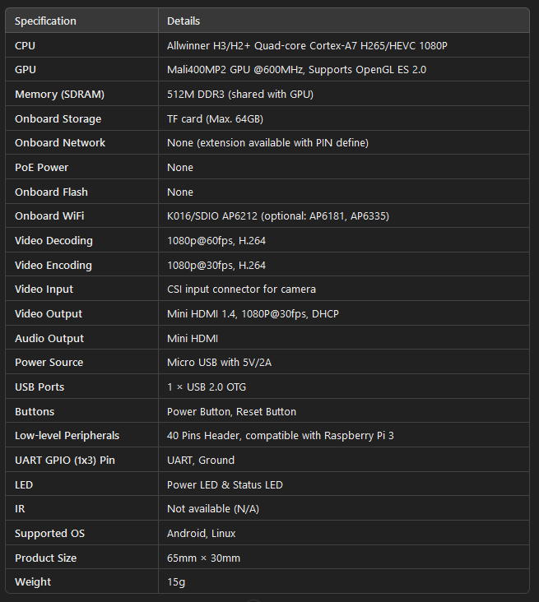
https://docs.banana-pi.org/en/BPI-M2_Zero/BananaPi_BPI-M2_Zero

Flipper WiFi Devboard
https://shop.flipperzero.one/products/wifi-devboard

Board Extensions

Screens
https://thepihut.com/products/triple-lcd-ips-hat-for-raspberry-pi
https://thepihut.com/products/1-3-ips-lcd-display-module-for-raspberry-pi-pico-240x240
https://thepihut.com/products/spi-3-5-320x480-ips-touch-screen-gpio
https://thepihut.com/products/2-8-touchscreen-display-for-raspberry-pi-pico-320x240

Power Supply
https://thepihut.com/products/uninterruptible-power-supply-ups-hat-for-raspberry-pi-zero
https://thepihut.com/products/lipo-battery-hat-for-raspberry-pi
https://thepihut.com/products/ups-module-for-raspberry-pi-pico-with-600mah-lipo-battery
https://thepihut.com/products/ups-module-for-raspberry-pi-pico-14500

NFC Modules
https://thepihut.com/products/nfc-hat-for-raspberry-pi-pn532

RFID Modules

Libraries

P4wnP1 A.L.O.A
- A framework which turns a Raspberry Pi Zero W into a flexible, low-cost platform for pen-testing.
- Last update was last year and before that was 4 years ago, may be outdated.
- Backed on Kali Linux, so all required tools should be there.
- Made with Go
https://github.com/RoganDawes/P4wnP1_aloa
https://www.kali.org/docs/arm/raspberry-pi-zero-w-p4wnp1-aloa/

https://hackaday.com/2021/07/21/its-linux-but-on-an-esp32/

Flipper Zero Tests
Get dimensions
Battery tests – Idle & Active
Test functionality

Compatibility Charts

Operating System
 | Raspberry Pi Zero 2 WH | Raspberry Pi Pico | Banana Pi BPI M2 Zero
Kali Linux | ✓ | X | ✓
Kali Net-hunter | X | X | ✓
Pi OS | ✓ | X | ✓
Pi-Tail | ✓ | X | X

Development Languages
 | Raspberry Pi Zero 2 WH | Raspberry Pi Pico | Banana Pi BPI M2 Zero
Go (TinyGo) | ✓ | ✓ | ✓
MiniPy | ✓ | ✓ | ✓

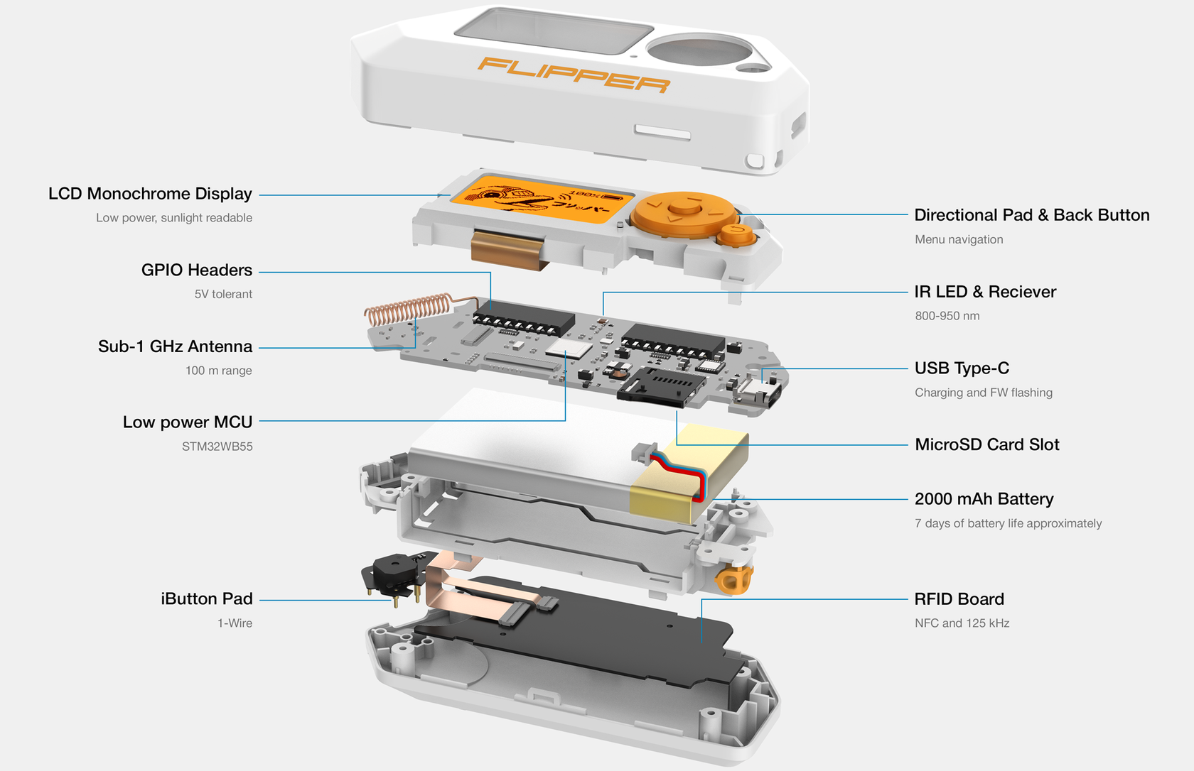
List of Items
Dev Board
https://www.reichelt.com/ie/en/shop/product/raspberry_pi_zero_2_wh_4x_1_ghz_512_mb_ram_wlan_bt-383360?PROVID=2854
NFC
https://www.waveshare.com/pn532-nfc-hat.htm
RFID
https://thepihut.com/products/rfid-hat-for-raspberry-pi
IR
https://thepihut.com/products/anavi-infrared-phat
Screen
https://www.waveshare.com/2.8inch-DPI-LCD.htm

